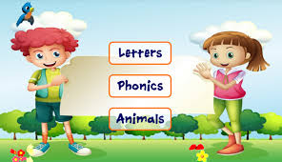Design and Code a Learning Game - ICS201 - Final Evaluation 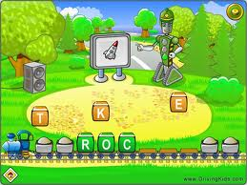
(Start: Introduced December 22, 2016 – Start January 9, 2016)
Programmer: ___________________ Due Date: January 20th, 2016

Current Level of Programming: ____ to ____ (get from teacher) Attempting: ____

Instructions:
This is worth 15% of your final mark. You are free to choose any project from level 1 up to the level that you have passed in the programming tests. Complete only ONE of the following level related projects. Mark Rubrics are posted in the ICS201 folder in the Final Evaluations Sub folder.

You will not be allowed to program until you hand in the completed template “Final Project Proposal and Algorithm” which is in the Final Evaluations folder in the class folder.

All programs that you create for this final evaluation will be saved on the H drive of your account. An important part of this evaluation is your process mark which will be assessed regularly.

Level 1: Introduce a unit for a subject of your choice using a 3 frame Comic Strip to primary level students: (0-59 marks)
- minimum of three frames (pictures and text)
- one must be animated (something changing)
- use readkey for transition to next frame
- use a variety of shapes
- user must make a choice (eg: what to animate / which frame to see / etc.)
- must show input, output, selection and repetition at the Level 1 Skill Level.
- hand in algorithm (keyed-in with a word processor) – ____________
- and hand-drawn pictures by ____________

Level 2: Math Quiz Show or Quiz Show for another subject of your choice for primary students:
(0-69 marks)
- a graphical math or another subject quiz for elementary students
- 7 questions using only addition OR 7 questions for subject of your choice
- questions must be in the form of pictures (eg:  2 apples +3 = ?) or related to another subject involving graphics and text
- graphical reward for each correct answer
- appropriate message displayed for incorrect answer
- goes to next question regardless of correct answer or not
- must use user’s name in questions and rewards
- must allow the user to try the test again
- must show input, output, selection and repetition at the Level 2 Skill Level.
- display the user’s score
- hand in algorithm (keyed-in with a word processor) – ____________

Level 3: Quiz Show-DELUXE on Math or any subject of your choice for primary or junior students:

(0-83 marks) 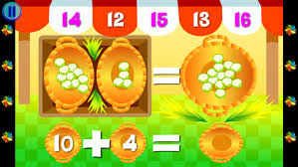
- a graphical math or another subject related quiz for elementary students
- an Animated Graphical Introduction (include quiz show instructions)
- your program will provide a Menu including a choice of addition, subtraction, and multiplication for math or another suitable menu for the subject of your choice
- 3 graphical (picture based) questions for each menu option that you provided
- You will need to come up with appropriate questions for the options you provide
- keep in mind that your program is being developed for elementary students, specifically for the age group that you have chosen to create the program
- graphical reward for each correct answer
- user should be given a choice if they want to attempt the question again or continue
- must use user’s name in questions and rewards
- must allow the user to try another operation
- must show input, output, selection and repetition at the Level 3 Skill Level.
- display the user’s score which keeps track of the correct answers and re-tries
e.g. Billy, you scored 9 out of 9, with 3 re-tries
- hand in algorithm (keyed-in with a word processor) by _____________

Level 4 : Create a learning game for two units of the subject of your choice or for one concept in two subject areas of your choice (84-100)

To achieve a level for mark you will design and create a learning game for two units of a subject area or for a unit in each of Math and English Language learning game for Elementary level students. This game should incorporate all level three requirements listed above and in addition must have some or all of the additional features listed below to get a mark in the range of 84-100. 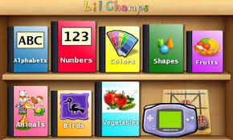

- a graphical learning game for elementary level students in a subject of your choice or in Math and English language
- The game is branded with your identity (who you are, name, personality, interests, ... (look at some of the learning games that are available in the market and on the web)
- an Animated Graphical Introduction (include game instructions)
- provides the choice to play the unit as in level 3 or the additional unit as in level 4.
- You have the choice to decide on what aspects that you would like the student to learn for each unit. (additional marks for those using a student to customize their program)
- Incorporates: Graphical User Interface and mouse routines
- Optional use of audio as oral instructions to guide the user or as a suitable background without distracting the user. The user should have the option to turn the sound off/on.
- Hand in Algorithm (keyed-in with a word processor) by __________________

Your game must display all Level 4 skills. Refer Programming Rubric for expectations.
Refer the marking rubrics for all assignments.

